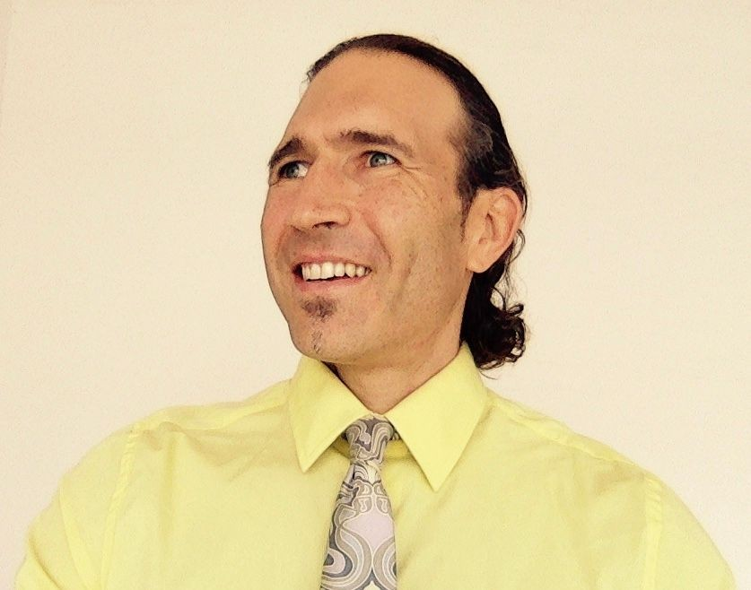
ADAM CARTER
EDUCATOR ◈ THOUGHT LEADER ◈ GLOBAL CITIZEN

Nationality: American DOB: September 12, 1974 Marital Status: Single
Address: Rhode Island, USA (currently Beijing, China)
Email: adrockisland@gmail.com
Phone: +8613269693009

Digital Resumé: www.cartersensei.com

PROFILE World-wide educator with a focus on creating engaging learning experiences in the classroom, while providing caring mentorship outside the classroom. Twenty years of humanitarian work, travel and teaching in over one hundred countries results in a wealth of teachable experiences in the classroom. Specialist in service learning, global citizenship, mindfulness and yoga in the classroom, with considerable edtech expertise. Created and operates a global philanthropic organization. A life-long learner with a deep interest in history, geography, languages, brain-based learning and global education. Combines constructivist approach with digital tools to foster 21st Century skills and high levels of academic achievement.

EDUCATION TEACH-NOW GRADUATE SCHOOL OF EDUCATION
Washington, DC — Master’s Degree in Education with Globalization Focus 2017-2018

GEORGE WASHINGTON UNIVERSITY — ELLIOT SCHOOL
Washington, DC — Master’s Degree, International Affairs 1999-2001

FULBRIGHT SCHOLAR
Spain — Independent research about socio-economic impact of African immigration in Spain 2001-2002

UNIVERSITY OF MICHIGAN
Ann Arbor, MI — Bachelor’s Degree and Honor’s Degree in Cultural Anthropology 1992-1996

EXPERIENCE MIDDLE SCHOOL/HIGH SCHOOL SOCIAL STUDIES TEACHER (6 YEARS)
Western Academy of Beijing (WAB), Beijing, China 2018-present
Taught 8th grade Language & Literature (IB) and Individuals & Societies (IB)
Middle School Service Learning Coordinator
Organized city-wide Global Issues Conference for 900 middle and high school students
Member of Senior Education Leadership Team
Organizing TEDxYouth Event

Schutz American School, Alexandria, Egypt 2014-2018
Taught World History, Geography and US History to 6th, 7th and 8th graders Developed “Global Issues: Becoming an Activist” course for 11th and 12th graders Helped design and roll out our 1:1 Chromebook initiative, the first in all of Egypt
Served as High School Model United Nations (MUN) Director and hosted four MUN conferences Developed a middle-school wide “Connect” class based on global citizenship and service learning
Served as faculty representative for Board of Directors to learn internal workings of international schools Integrated mindfulness in classroom in form of “Mind & Body” club and advisory units
Created and took on role of school-wide Service Learning Coordinator

TEACHER TRAINER
Teach-Now Virtual Mentor for Prospective Teachers, Teach-Now, Washington, DC 2018-2019
Guided 3-month student teaching portion of teaching certification by helping candidates hone
teaching skills and improve their practice; assessed their progress based on rubrics and reflection

CURRICULUM DEVELOPER
X-School, Beijing, China 2018-present
Develop project-based learning curriculum for social studies, art and innovation classes for ages 7-12
Created Global Competency Camp for high school students, incorporating project-based learning,
social entrepreneurship and public speaking

HIGH SCHOOL ESL TEACHER - JAPAN EXCHANGE & TEACHING PROGRAM (1 YEAR)
Meiokan, Kagoshima, Japan 2013-2014
Taught English language class to 650 students in public high school. Directed conversational training classes and assisted in the language training of Japanese Teachers of English.

NON-PROFIT FOUNDER & CHAIRMAN (10 YEARS)
Cause & Affect Foundation (www.causeandaffectfoundation.org) 2009-present
Created and manage a non-profit foundation; designed website, blog and handle public relations and outreach efforts. Worked with schools in Latin America, Asia, North America and Africa to develop service learning projects and promote global awareness amongst students. Appeared as guest speaker at conferences and educational conventions; wrote several newspaper and magazine articles, in addition to multiple television and radio appearances.

CERTIFICATIONS TEACHING CREDENTIAL, SOCIAL STUDIES 7-12, DISTRICT OF COLUMBIA Current
ETS Recognition of Excellence Award for PRAXIS Social Studies
International Baccalaureate Language & Literature Level 1 Certification, 2018
International Baccalaureate DP Theory of Knowledge (TOK) Certification, 2018
Mindful Educator Essentials Certification (Mindfulschools.org), 2019
Mindfulness in Schools Project: Teach dot B (11-18) Certification (Mindfulnessinschools.org), 2014
YogaMinded: Yoga 4 Teens Teaching Certification, 2017 Flat Connections Global Educator Certification, 2014 TEFL/TESL Certification, Accreditat, 2013
ESA First Aid Certification, 2017
Flipped Classroom Certification, Capella University, 2014 Teaching With Tablet Certification, Capella University, 2014
International Baccalaureate (IB) Diploma, Lincoln Park High School, Chicago, IL 1992

PRESENTATIONS Future of Education Now Conference at Western Academy of Beijing, November 2019: The Changing Role of
Students from Media Consumers to Media Creators
Global Education Conference, November 2019: Using Media Creation as a Teaching Tool
21st Century Learning Conference, Hong Kong, March 2019: Turning Ideas into Action: How to Create your own Charity Project
Near East South Asia Council of Overseas Schools (NESA) Spring Educators Conference, Istanbul, March 2015: Let’s Go Global: Instilling Global Citizenship in the Classroom
Central and Eastern European Schools Association (CEESA) Annual Conference, March 2017: Putting the Learning Back in Service Learning
Qatar Leadership Conference, October 2015: Service Learning: How to Create Positive Change in and out of School
Global Educational Conference, November 2014: Tips on Designing a Global-focused Class Presenter at Learning Revolution Conference, April 2014: Instilling Global Citizenship Inside and Outside of the Classroom
Keynote Speaker at SAS Leadership Conference, May 2016: Turning Your Passion into a Lifestyle Distinguished Speaker at Bill Clinton School of Public Service, 2010: The Beerman Philanthropist Keynote Speaker at Phi Theta Kappa Regional Convention, 2013: Everyone Can Be a Student Activist
PUBLICATIONS Student-Centered Service Learning, EARCOS Journal, Spring 2018
Four Steps for Transforming Students into Young Activists, Education Week: Global Education Spotlight, July 6, 2017
Putting Compassion Into Action: Week Without Walls, Near East South Asia Council of Overseas Schools (NESA) Newsletter, Volume 18, Number 1 Fall 2015
Reflection on Schutz’s 1:1 Chromebook Initiative, Near East South Asia Council of Overseas Schools (NESA) Newsletter, Volume 19, Number 1, Fall 2016:
Learn, Collaborate, Empathize and Make a Difference: An Interactive Approach to Learning About the Syrian Refugee Crisis, Near East South Asia Council of Overseas Schools (NESA) Newsletter, Volume 19 Number 1, Fall 2016
Tear Down That Wall: Joining the Global Classroom Community to Instill Global Citizenship, Edutopia.com, March 25, 2014
A Successful Service Learning Approach to the Syrian Refugee Crisis, Edutopia.com, November 17, 2016 Instilling Global Citizenship Within the International School Network, Global Education Magazine, December 10, 2013
Personal Passion Project, International School Services News Links Newsletter, October 2016
The Best Ways to Create a 21st Century Learning Environment, Howtolearn.com, December 22, 2013 Discovery Days: An Innovative Multidisciplinary Approach to Learning, April 5, 2017, International Educator Online Featured Article
Featured in the book Power of Philanthropy, by Justin Sachs, Motivational Press, 2010.

RESEARCH Master’s Thesis: “An Action Research Analysis of the Global Competency Learning Continuum (GCLC)”
Panel Expert for 2015 & 2016 NMC/CoSN Horizon Report K-12 about edtech trends

REFERENCES Marina Fria-Gavidia, Middle School Principal, Western Academy of Beijing
email: mfrias@wab.edu; work phone: +201286796760
Randa Shoeb, Middle School Principal, Schutz American School
email: rshoeb@schutzschool.org.eg; work phone: +2035762205
Bill Docker, Mentor, Provincetown, MA, USA
email: bdocker@comcast.net; work phone: +15082375871

